RAGLAN ART AWARDS 2023
Sponsored by The Raglan Gallery
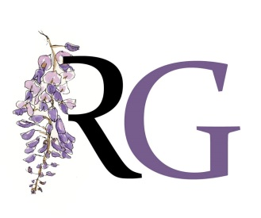 | ENTRY FORM
Entry forms to the Raglan Galley by Wed May 24th 2023
DATES: Entries delivered by Mon 5th JUNE 2 |  | OPENING: 10th JUNE
THEME “On the UP!”
Artist’s Name……………………………………………………………………………………………………..
Address……………………………………………………………………………………………………….…….. Postcode……………………………………..
Phone…………………………………………….. Email…………………………………………………………………………………………….………………

I am a Friend (Member) of the Raglan Note: $30 per entry - 2 entry limit

Artist Payment Details for Direct Deposit | BSB : | ACCT :

I understand and acknowledge the terms and conditions of entering the Raglan Art Award

Signed ……………..…………………………………………………………. Date …………………………….……………….…………….………………
ARTWORK 1  Title……………………………………………………………………………………  Medium……………………………………………………………………………..  Price $.................................................................................... | ARTWORK 2  Title……………………………………………………………………………………  Medium……………………………………………………………………………..  Price $....................................................................................
ENTRY FEE TOTAL $................... ($30 PER WORK ENTERED)
- Entry fee : cash at Raglan Gallery OR
- by direct deposit to BSB 032720 : Account 222732 (Westpac Cooma) - reference RAA and YOUR NAME .
IMPORTANT DATES
Completed Entry Forms must be received by  3.30pm Wed 24th May | Artwork Delivered By Monday 5th June
Judging – Friday 9th June | Opening – 3pm Saturday 10th June - all invited
Exhibition Closes and work to be picked up Sunday 16th July / Monday 17th or Tuesday 18th July
RAGLAN ART AWARD PRIZES FOR 2023
1st $1,000 best in show, any medium | 2nd $600 any medium | 3rd $400 any medium

