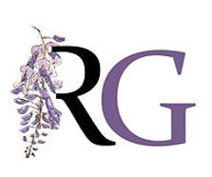  Raglan Gallery Exhibitions PART 1 2024  Opening Hours:  Wednesday - Sunday 10:30am - 3:30pm |  | 9-11 Lambie Street, Cooma NSW  (02) 6452 3377
End of March Mitchell Gallery
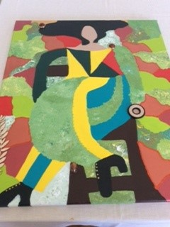
“Just for Members”
Merilyn Minell, Matthijs de Ruiter, Michelle Warby, Jocelyne Godber, Finn Stensrud, Rasa Maugris, Julie Field, Katrin Hackney, Gillian Jenkins,

“It’s Only Rock’n’roll but I like it” Wendy McDougall

Jan 1st – 25th Feb Tillers Gallery
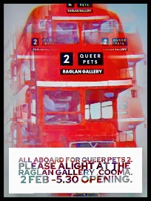
“Queer Pets Two” Gillian Jenkins, Belinda Streete, Leanne Gai

Inspired by Australian performer Magda Szubanski’s character “Lynne Postlethwaite” whose famous phrase was “I said love I said PET” . The inaugural Queer Pets exhibition was the first LGBTQIA exhibition in the Cooma SM region. Queer Pets Two is an exhibition that asked the artists to respond to “Identity in Place”
Opening function at 5:30 -7:30 2/3/24
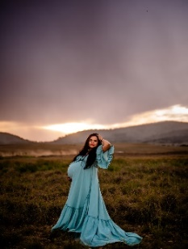
Feb 29th Feb - March 24th Tillers Gallery
KATIE PHILLIPS “Mummahood” Photography

It's a love letter to Mums. It's a moment to switch on the light so now we see Mum. We see her with her most precious ones. We see her radiance and strength. We hear her story of love, pain, sacrifice, resilience, power and courage. And we say thank you.

Opening function at 5:30 – 7:30 on Frid 8th March on International Woman’s Day 8th March
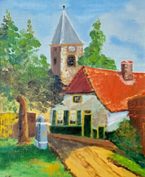
March 27th - May 12th Tillers Gallery
“Between Cultures” - Van der Plaat family
Elida, Arno, Deborah and Brian Van der Plaat. The exhibition brings together paintings and drawings produced by 3 generations of the one family. The output of an émigré family who migrated from the Netherlands to Australia in the 1950’s .) The work displayed includes multiple genres (landscape paintings, still life and figure drawing) and moves from the visual arts to architectural design .
Opening Function at 3pm Easter Saturday 30th March
April 17th – May 20th Mitchell Gallery
“Almost Real” - Margot Sears
3D lenticular transgender portraits

Opening 5 – 7 pm pm Friday 19 ^{th} April

May 15th - June 30TH Tillers and Mitchell Galleries

CLIMATE ACTION MONARO ART AWARDS
“ Imagine A Clean Energy Future “

Entry forms due Thursday 9th May, delivered by Monday 13th May

Opening and Awards presentation 3pm Sat 18th May

